

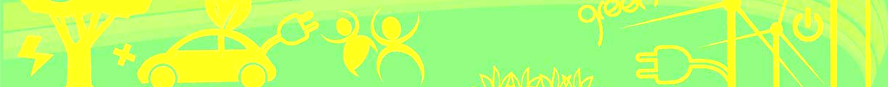
5th International Conference on (PESA)
Power Electronics Systems and Application 2013
TECHNICAL VISIT REGISTRATION FORM
Part I – PERSONAL INFORMATION
First Name: |  |  |  |  | Prof. / Dr. / Ir. / Mr. / Ms
Surname:
Mail Address:
Mobile: |  |  |  | Phone: |  |  |  | Fax:
Email: |  |  |  | Paper No: (If applicable)
Institute/Company:
Department: |  |  |  |  | Position
Part II – Technical Visit Program
Technical Visit (Please tick the box(s) below)
 |  |  |  |  |  |  | For Conference delegate  Free |  | For friend and Accompany guest  $100 each
Morning:  09:15am – 10:15 am  CLP Ppwer | CLP Power: Smart Grid  Development Centre | Morning:  10:20 – 11:20 |  | CLP Power: Power Quality Centre
Lunch | Chinese Restaurant in ShamShuiPo
Afternoon:  15:30 – 16:30pm  Science Park | Hk Science and Technology Park  InnoNest | Afternoon:  16:30 – 17:30pm | CKK Showcase  Green Concept Showcase
Total Fee : |  |  |  |  |  | NIL
Payment method：
1. Cheques should be made payable to “The Hong Kong Polytechnic University”. Please mark ‘PESA 2013 Conference’, <your name> and <conference paper number> at the back of the cheque. Please mail to: Ms Kit Chan, Secretariat of PESA Conference, Department of Electrical Engineering, The Hong Kong Polytechnic University, Hung Hom, Hong Kong.
2. Credit card payment is also accepted, use the form next page.
3. Once the application is accepted by the organizer, participation fee will not be returned.
Remarks：
1. Participation fee includes to Lunch and transportation.
Signature:
Part III - REMINDER
Please attach the following items to register:
- Conference technical Visit Registration Form Cheque number (if neded) ::
- Credit Card Payment Form (next page, if needed )

HOW TO REGISTER: Send the registration form to us
Post | Phone | Fax | Email
Dept of EE, The Hong Kong Polytechnic University, Hung Hom, Hong Kong | (852) 3400 3348 | (852) 2330 1544 | eepesa13@connect.polyu.hk

PESA2013 |  | 5th International Conference on Power Electronics Systems and Applications http://perc.polyu.edu.hk/pesa2013
Credit Card Payment Form:
To: PESA2013 Secretariat, Department of Electrical Engineering, The Hong Kong Polytechnic University

Please charge my/our credit card with the amount |  |  |  |  |  |  |  |  |  |  |  |  |  |  |  |  | HK$
Type of Credit Card: |  |  |  |  |  |  |  |  |  |  | VISA |  |  |  |  |  |  |  |  |  |  |  |  |  |  | Master
Card Number: |  |  |  |  |  |  |  |  |  |  |  | - |  |  |  |  |  |  |  |  |  |  | - |  |  |  |  |  | -
Card Expiry Date: |  |  |  |  |  |  | /
Signature of Card Holder
Name on the card:
Address on the card:
Telephone Number: |  |  |  |  |  |  |  |  |  |  |  |  |  | Fax Number
Email Address
Paper Numbers
Remark(if any):
This form can be photocopied.

